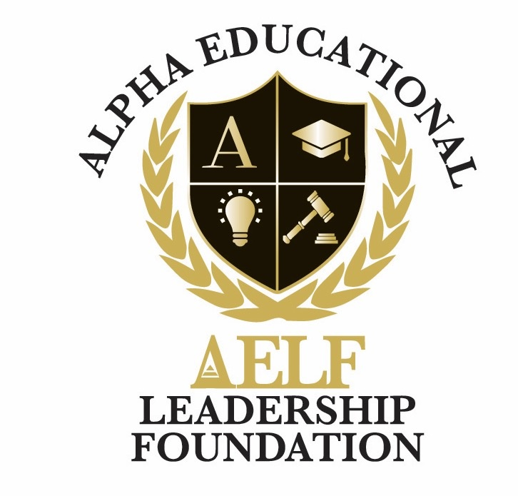
ALPHA EDUCATIONAL & LEADERSHIP FOUNDATION, INC.
3370 Capital Circle N.E., Suite C-1, Tallahassee, Florida 32308 • (850) 296-7948
EIN: 59-3560158 • A 501(c)(3) Nonprofit Organization
Terms of Use & Website Disclaimer
Adopted: June 2026
These Terms of Use ("Terms") govern your access to and use of aelfoundation.org and any related digital properties operated by the Alpha Educational & Leadership Foundation, Inc. ("AELF"). By using the site, you agree to these Terms.

1. Informational Purpose
The content on this website is provided for general informational, educational, and charitable-engagement purposes. It does not constitute legal, financial, tax, medical, or professional advice. You should consult a qualified professional for advice specific to your situation.

2. No Warranties
AELF makes reasonable efforts to ensure information on this site is accurate and up to date, but makes no warranties or representations, express or implied, regarding completeness, accuracy, reliability, or fitness for a particular purpose. Site content is provided "as is" and "as available."

3. Limitation of Liability
To the fullest extent permitted by law, AELF, its directors, officers, employees, and volunteers shall not be liable for any direct, indirect, incidental, consequential, or punitive damages arising out of your access to, use of, or inability to use this website or any linked resources.

4. Third-Party Links and Content
This website may contain links to third-party sites (including donation platforms, social media, and partner organizations). AELF does not control and is not responsible for the content, privacy practices, or accuracy of third-party sites. Links are provided as a convenience and do not imply endorsement.

5. Intellectual Property
All text, graphics, logos, images, and other content on this site are the property of AELF or its licensors and are protected by copyright and trademark laws. You may share or print content for personal, non-commercial, and educational use with attribution. All other uses require prior written permission.

6. User Conduct
You agree not to use the website to transmit unlawful, harassing, defamatory, or harmful content; to interfere with site security or performance; or to violate any applicable law.

7. Donations
Donations are processed through trusted third-party platforms. AELF is a recognized 501(c)(3) organization (EIN 59-3560158); contributions are tax-deductible to the extent allowed by law. Please retain receipts for tax purposes and consult your tax advisor.

8. Photography and Media Release
Photos, videos, and quotations featured on this site are used with appropriate consent from participants or their guardians. If you believe content involving you or your child should be removed, please contact us.

9. Changes to the Site and Terms
AELF may modify, suspend, or discontinue any portion of the site at any time. We may update these Terms periodically; continued use after revisions constitutes acceptance of the updated Terms.

10. Governing Law
These Terms are governed by the laws of the State of Florida, without regard to its conflict of laws principles. Any dispute shall be resolved in the state or federal courts located in Leon County, Florida.

11. Contact
Questions regarding these Terms may be directed to news@aelfoundation.org.

