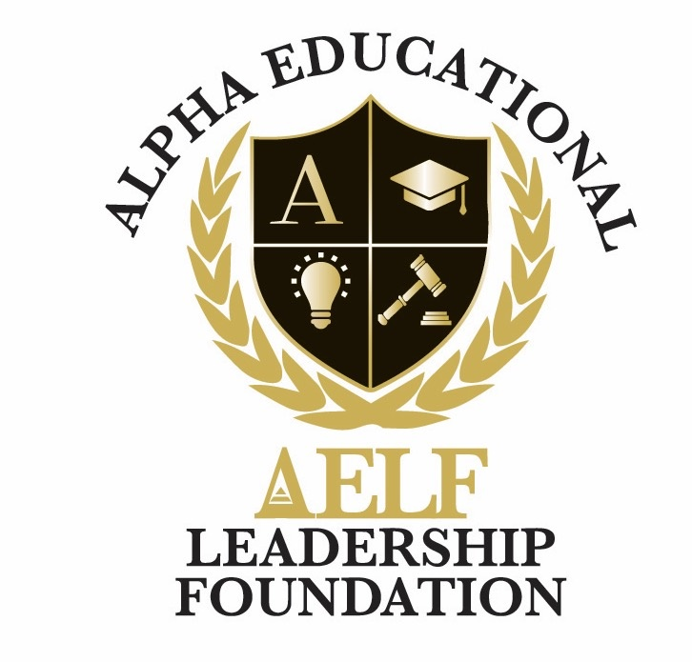
ALPHA EDUCATIONAL & LEADERSHIP FOUNDATION, INC.
3370 Capital Circle N.E., Suite C-1, Tallahassee, Florida 32308 • (850) 296-7948
EIN: 59-3560158 • A 501(c)(3) Nonprofit Organization
Non-Discrimination Statement
Adopted: June 2026
The Alpha Educational & Leadership Foundation, Inc. ("AELF") is committed to providing an inclusive, respectful, and equitable environment for all scholars, families, volunteers, employees, donors, and community partners.

Policy
AELF does not discriminate on the basis of race, color, religion, national origin, ancestry, sex, gender, gender identity or expression, sexual orientation, age, marital status, veteran status, disability, genetic information, pregnancy, or any other characteristic protected by applicable federal, state, or local law.
This policy applies to all aspects of the Foundation’s programs and operations, including scholarship and program admissions, mentoring, hiring and employment, volunteer engagement, vendor selection, board service, and access to facilities and services.

Equal Opportunity in Programs
All youth and families who meet program eligibility requirements are welcomed and considered without regard to the protected categories listed above.

Equal Opportunity in Employment and Volunteering
AELF provides equal opportunity in recruitment, hiring, training, promotion, compensation, and volunteer placement in accordance with applicable law.

Accessibility and Accommodations
Reasonable accommodations will be provided to qualified individuals with disabilities to enable participation in our programs and operations. Requests for accommodations may be directed to the contact information below.

Reporting Concerns
Any individual who believes they have experienced or witnessed discrimination involving AELF is encouraged to report the concern to news@aelfoundation.org or (850) 296-7948. Reports will be reviewed promptly and confidentially to the extent possible, and no retaliation will be tolerated against any person who in good faith reports a concern.

