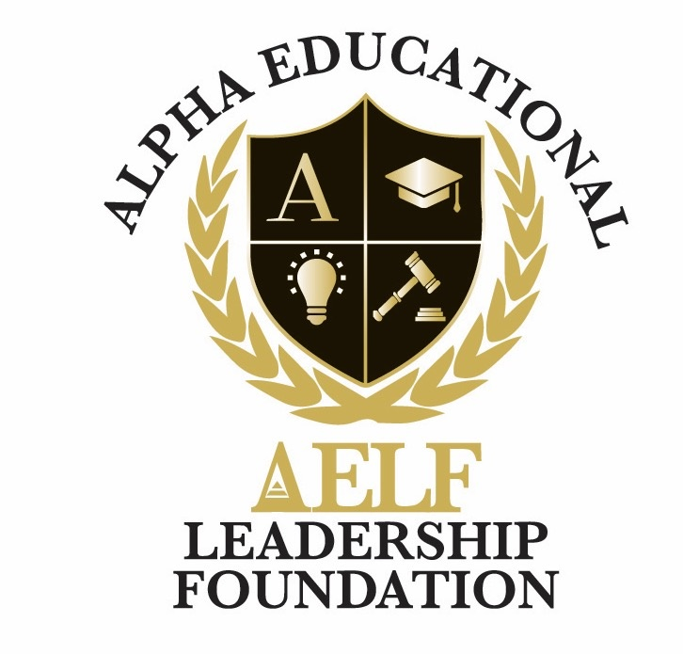
ALPHA EDUCATIONAL & LEADERSHIP FOUNDATION, INC.
3370 Capital Circle N.E., Suite C-1, Tallahassee, Florida 32308 • (850) 296-7948
EIN: 59-3560158 • A 501(c)(3) Nonprofit Organization
Gift Acceptance Policy
Adopted: June 2026

1. Purpose
The Alpha Educational & Leadership Foundation, Inc. ("AELF") solicits and accepts gifts that are consistent with its mission to advance the educational, leadership, entrepreneurial, and health development of youth and adults. This Gift Acceptance Policy governs the acceptance of gifts and provides guidance to donors and their advisors.

2. Mission Alignment
All gifts must be consistent with AELF’s mission, values, and tax-exempt purposes. AELF reserves the right to decline any gift that is inconsistent with these criteria or that would create unacceptable administrative, legal, financial, or reputational burdens.

3. Types of Gifts Generally Accepted
- Cash, checks, and electronic transfers (including credit/debit card and online platforms such as Zeffy);
- Publicly traded securities;
- Bequests and beneficiary designations through wills, trusts, retirement accounts, and life insurance policies;
- Matching gifts and corporate sponsorships;
- In-kind donations of goods or services directly useful to AELF’s programs (subject to approval).

4. Gifts Requiring Board Review
- Real estate or tangible personal property of significant value;
- Closely held securities, partnership interests, or other non-publicly-traded assets;
- Gifts with restrictions, naming rights, or unusual conditions;
- Gifts requiring AELF to assume ongoing obligations, debt, or significant maintenance costs.

5. Gifts Not Accepted
AELF will not accept gifts that:
- Are inconsistent with the Foundation’s mission or values;
- Could expose the Foundation to legal liability, regulatory penalties, or undue reputational harm;
- Would violate any federal, state, or local statute, regulation, or ethical standard;
- Are from sources whose business activities are incompatible with AELF’s charitable purposes.

6. Donor Acknowledgment and Receipts
AELF will provide written acknowledgment of all gifts in compliance with IRS requirements. Donors are responsible for obtaining their own independent legal and tax advice regarding the value and tax treatment of any contribution.

7. Restricted and Designated Gifts
Restricted gifts will be used solely for the purposes specified by the donor and as accepted by AELF. If circumstances make a restricted purpose impracticable, AELF will work in good faith with the donor or the donor’s representatives to redirect the funds to a closely aligned purpose.

8. Anonymous Gifts
AELF respects donor requests for anonymity and will preserve donor confidentiality consistent with legal and audit obligations.

9. Policy Review
This Policy shall be reviewed periodically by the Board of Directors and amended as necessary.

