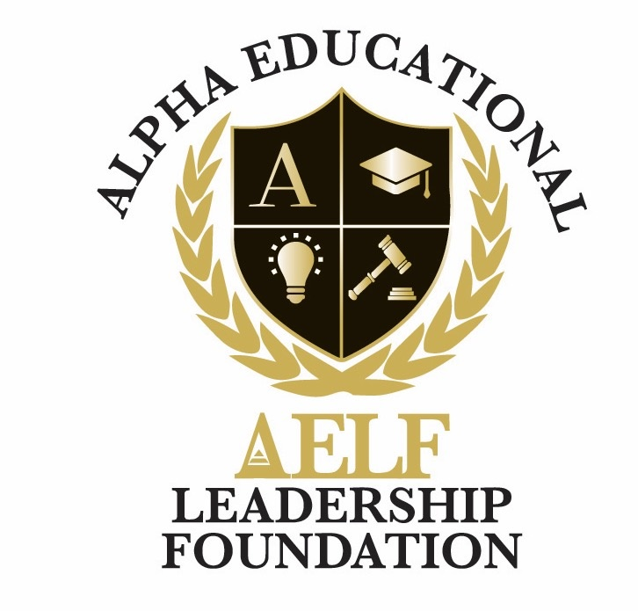
ALPHA EDUCATIONAL & LEADERSHIP FOUNDATION, INC.
3370 Capital Circle N.E., Suite C-1, Tallahassee, Florida 32308 • (850) 296-7948
EIN: 59-3560158 • A 501(c)(3) Nonprofit Organization
Document Retention & Destruction Policy
Adopted: June 2026

1. Purpose
This Document Retention and Destruction Policy of the Alpha Educational & Leadership Foundation, Inc. ("AELF") provides for the systematic review, retention, and destruction of records received or created in the course of AELF’s operations. It is intended to ensure that the Foundation complies with applicable legal requirements, preserves records of enduring value, and disposes of records that are no longer needed.

2. Scope
This Policy applies to all physical and electronic records generated by AELF, including paper documents, emails, digital files, photographs, and audio/video recordings.

3. Retention Schedule (Summary)

Corporate / Governance Records — Permanent
Articles of Incorporation, Bylaws, IRS determination letter, board minutes, conflict-of-interest disclosures, annual reports.

Financial Records — 7 Years
General ledgers, journals, accounts payable/receivable, bank statements, invoices, expense reports, payroll records, and audit reports.

Tax Records — 7 Years
Annual Form 990 filings, supporting workpapers, and donor acknowledgment letters.

Donor Records — 7 Years
Donation receipts, pledge documentation, grant agreements, and donor correspondence.

Program & Scholarship Records — 7 Years after program close
Applications, recommendation letters, award letters, transcripts, and program evaluations.

Employment Records — 7 Years after separation
Personnel files, time records, benefits enrollment, and termination documentation.

Insurance Records — Permanent for policies; 7 years for claims
Liability, D&O, and property insurance policies; claim correspondence and supporting documents.

Routine Correspondence — 3 Years
Routine emails and letters not related to legal, financial, or governance matters.

4. Destruction
Records that have met their retention period and are not subject to a legal hold will be destroyed in a manner that protects the confidentiality of donors, scholars, and staff. Paper records will be shredded, and electronic records will be permanently deleted.

5. Legal Hold
No record shall be destroyed if it is the subject of an investigation, audit, litigation, or anticipated litigation. The Executive Director or Board Chair shall promptly notify staff of any legal hold.

6. Compliance
Failure to comply with this Policy may subject AELF to penalties and fines, and may result in disciplinary action against responsible individuals.

