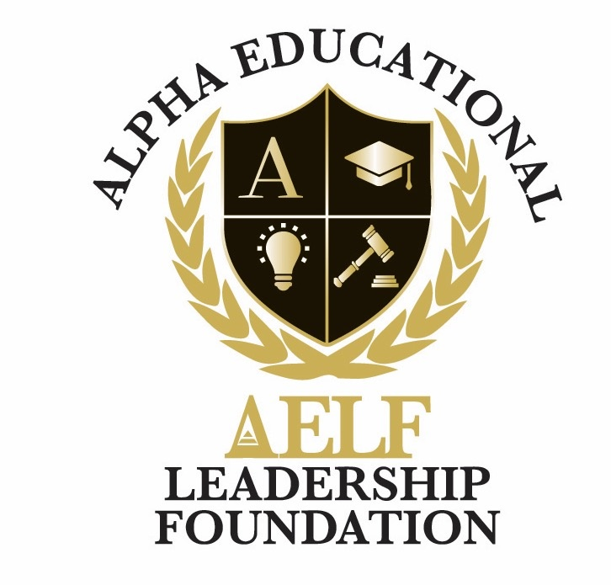
ALPHA EDUCATIONAL & LEADERSHIP FOUNDATION, INC.
3370 Capital Circle N.E., Suite C-1, Tallahassee, Florida 32308 • (850) 296-7948
EIN: 59-3560158 • A 501(c)(3) Nonprofit Organization
Privacy Policy
Adopted: June 2026
This Privacy Policy describes how the Alpha Educational & Leadership Foundation, Inc. ("AELF," "we," "us," or "our") collects, uses, and protects information when you visit aelfoundation.org or interact with our programs, donation forms, newsletters, and member portals.

1. Information We Collect
- Contact information you provide voluntarily (name, email, phone, mailing address) when you donate, register for events, subscribe to our newsletter, apply to our programs, or contact us.
- Donation and transaction information processed through our third-party payment platforms (such as Zeffy). Full payment card numbers are handled directly by those processors and are not stored on our servers.
- Program participant information including student applications, recommendation letters, and parent/guardian contacts, used solely to administer scholarships and programming.
- Website usage data such as IP address, browser type, pages viewed, and referring URLs, collected through standard analytics tools to help us improve the site.

2. How We Use Information
- To process donations, send receipts, and acknowledge contributions.
- To administer scholarship programs, mentoring, and educational events.
- To send newsletters, program updates, and impact reports to subscribers (you may unsubscribe at any time).
- To respond to inquiries and provide information requested by you.
- To comply with legal, tax, and reporting obligations of a 501(c)(3) organization.

3. Information Sharing
We do not sell, rent, or trade personal information. We may share information only:
- With service providers (payment processors, email platforms, analytics) that help us operate, under confidentiality and data-protection terms;
- When required by law, subpoena, or to protect the rights, safety, or property of AELF, our scholars, or the public; or
- With your consent (for example, when you agree to be featured in a scholar spotlight).

4. Cookies and Analytics
Our website may use cookies and similar technologies to remember preferences and measure traffic patterns. You can disable cookies in your browser settings; some features of the site may not function as intended without them.

5. Data Security
We use reasonable administrative, technical, and physical safeguards to protect personal information. No method of transmission over the Internet is 100% secure, however, and we cannot guarantee absolute security.

6. Children’s Information
Because we serve youth, we collect minors’ information only with parental or guardian consent in connection with program enrollment. We do not knowingly collect personal information from children under 13 through the public website outside of these supervised program contexts.

7. Your Choices
- You may request access to, correction of, or deletion of your personal information by emailing us.
- You may unsubscribe from emails using the link in any message or by contacting us directly.

8. Third-Party Links
Our site may link to third-party websites (such as Zeffy or social platforms). We are not responsible for the privacy practices of those sites; please review their policies separately.

9. Changes to This Policy
We may update this Policy from time to time. The "Adopted" date above will reflect the most recent revision.

10. Contact Us
Questions about this Privacy Policy should be directed to news@aelfoundation.org or 3370 Capital Circle N.E., Suite C-1, Tallahassee, Florida 32308.

